Xiaoru Chen

chenxia2@oregonstate.edu

Project #3

CS 475/575

2021-05-05

1. My own choice quantity is the number of earthworms: **NowNumEarthworm.**

I assume that the earthworm has an positive effect on the soil, because it loosens the soil.

An earthworm will increase the height of the Grain a little bit each month. But the number of earthworm is also impacted by precipitation and temperature. I set that if the temperature in Celsius is higher than the height of precipitation in centimeter, then the number of earthworms will decrease by 3 per month; If the temperature in Celsius is lower than the height of precipitation centimeter, the number of earthworm will increase by 1 every month.

Because the amount of earthworms is impacted by temperature and precipitation, and earthworms affect the height of grains, and the height of grain also affects the amount of deer.

It fits into the simulation.

The initial number of earthworms is 50.

2. Table of Results:

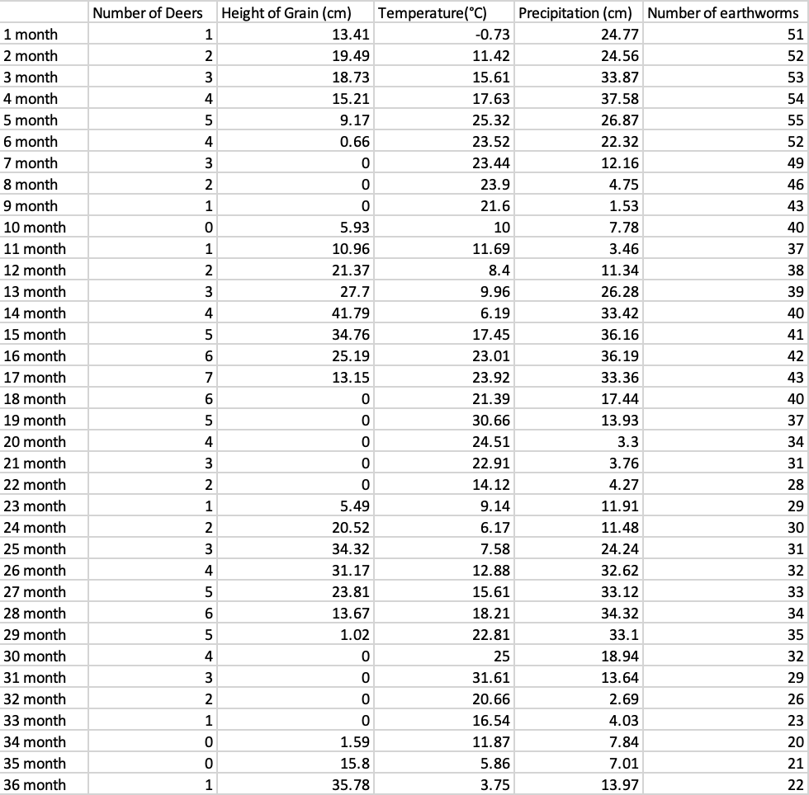

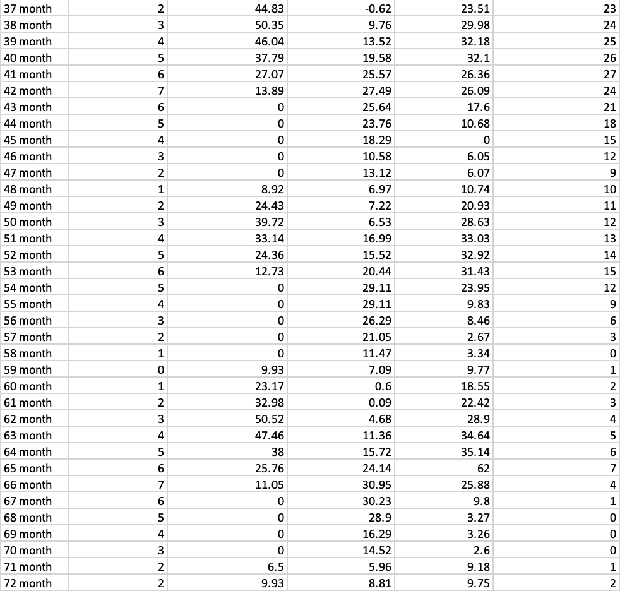Fig 1. Table showing values for temperature, precipitation, number of deer, height of the grain, and my own-choice quantity.

3. Graph of Results:

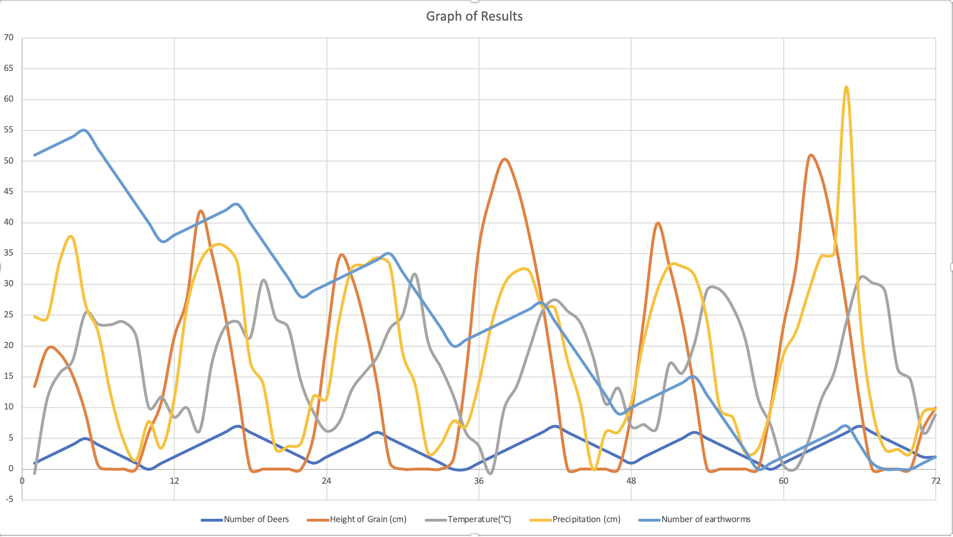

Fig. 2 A graph showing values for temperature, precipitation, number of deer, height of the grain, and my own-choice quantity.

4.

As the temperature and precipitation increase, so does the height of grain.

If the number of deer is lower than the height of grain, then number of deer increases each month as shown in the graph and table.

When the number of deer is larger than the height of grain in inches, the number of deer decreases each month as shown in the graph and table.

At the same time, earthworms can also help grain grow.

As long as the number of earthworms does not decrease to 0, it will always have a positive influence on the height of grain, which may also decrease due to temperature and precipitation factors.

When the temperature in Celsius is lower than the precipitation in centimeters, the number of earthworms increases.

When temperature in Celsius is higher than precipitation in centimeters, the number of earthworms decreased.

Here is an evidence in the curves proves that my own quantity is actually affecting the simulation correctly:

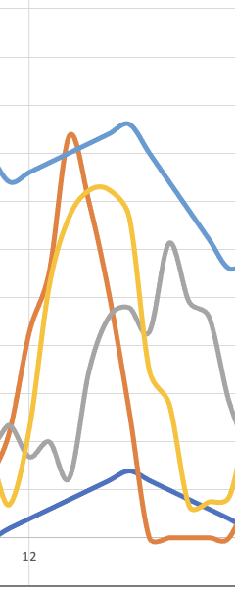

In the graph, from about 11 to 17 months, the number of earthworms (light blue line) increases when the temperature (gray line) is lower than the precipitation (yellow line). Then, when the temperature (gray line) is higher than precipitation (yellow line) in the 17th to 22nd months, the number of earthworms (light blue line) decreases. Therefore, it is actually affecting the simulation correctly.